1929 Hupmobile work list.

This is only a visual inspection of things that I could use or need at this time.
My plan is to start restoration work around summer of ‘06 after research is done.

- Is there any sure why to determine the Model of these cars, I do know that she is either a Century 6 or a Model A from 1928, but with one.

- Will need at least one hood locking clamp
- Will need at least two hub caps (for rear wheels, if they differ)
- Will need a Radiator.
- Most likely will need a to rebuild the engine or at least a copper head gasket for a 6 cylinder.
- Will need all new tires and inner tubes.
- Needs both sets of spare tires, (Tires, tubes, Rims/wheels, tie downs?, and covers?)
- This Hupp has a pair of spar tires, one on either side of engine.
- Front Fender: I believe that they are repairable, but with quite a bit of work.
- Both front finders have the spar tire space, however these inverted fender areas are shot and will have to be replaced or new fenders will have to be used.
- Runner boards aren’t great, However I do not know what I will need for this area.
- Most likely will need Window shades.
- Of course the following general maintenance parts like: Brakes and Tune-up stuff.
- Needs the passenger rear bumper mounting bracket.
- Moe-hair cloth for the interior (Green)
- Vinyl rooftop material or what ever has used back then.
- Painting schemes and paint formulas
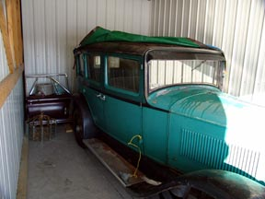
- Photos:

